**HOME SECURITY ALARM SYSTEM USING ARDUINO**

**INTRODUCTION:**

Security system is one of the important features of modern residential and office setups. Every person wants his home, bank, and his personal things safe. But now a days the possibility of intrusion and burglar are increasing. Arduino based home security system is a cheap and effective way of protecting your home. It uses an advanced microcontroller technology to alert you about burglary by a motion sensor by the changing surrounding ambient temperature.

**HOME SECURITY ALARM SYSTEM USING ARDUINO:**

The aim of this project is to implement a simple and affordable, but efficient home security alarm system. The project is designed for detecting intruders and informing the ownerwhen someone enters your house by detecting the heat produced by the body. When the system is switched on, it detects the motion of intruder, it alerts you by producing an alarm using a buzzer. If the switch is in off condition, the system does nothing. So, when we are not around and want to protect your house from this threat we can switch on the system.

A PIR sensor (passive infrared sensor)is used in this system to detect the motion and the detected information is sent to the microcontroller where it is processed and determine if there is a person or not. If it finds any motion, it sends a signal to the buzzer to alert. If there is no detection found by the sensor, the circuit does nothing.

**WORKING:**

PIR sensors are more complicated than many of the other sensors explained in these tutorials (like photocells, FSRs and tilt switches) because there are multiple variables that affect the sensor’s input and output. The PIR sensor itself has two slots in it, each slot is made of a special material that is sensitive to IR. The lens used here is not really doing much and so we see that the two slots can ‘see’ out past some distance (basically the sensitivity of the sensor). When the sensor is idle, both slots detect the same amount of IR, the ambient amount radiated from the room or walls or outdoors. When a warm body like a human or animal passes by, it first intercepts one half of the PIR sensor, which causes a positive differential change between the two halves. When the warm body leaves the sensing area, the reverse happens, whereby the sensor generates a negative differential change. These change pulses are what is detected. Arduino NANO is the microcontroller used in this project. The detected signal from PIR sensor is sent to the Arduino Nano and get processed. All living being with a temperature above absolute zero emits heat energy in the form of radiation. These radiations are detected by the PIR sensor. If the sensor detects infrared radiation, the microcontroller sends electric signal to the buzzer. If no radiations were detected, the system continues to detect radiations.

**CIRCUIT DIAGRAM:**

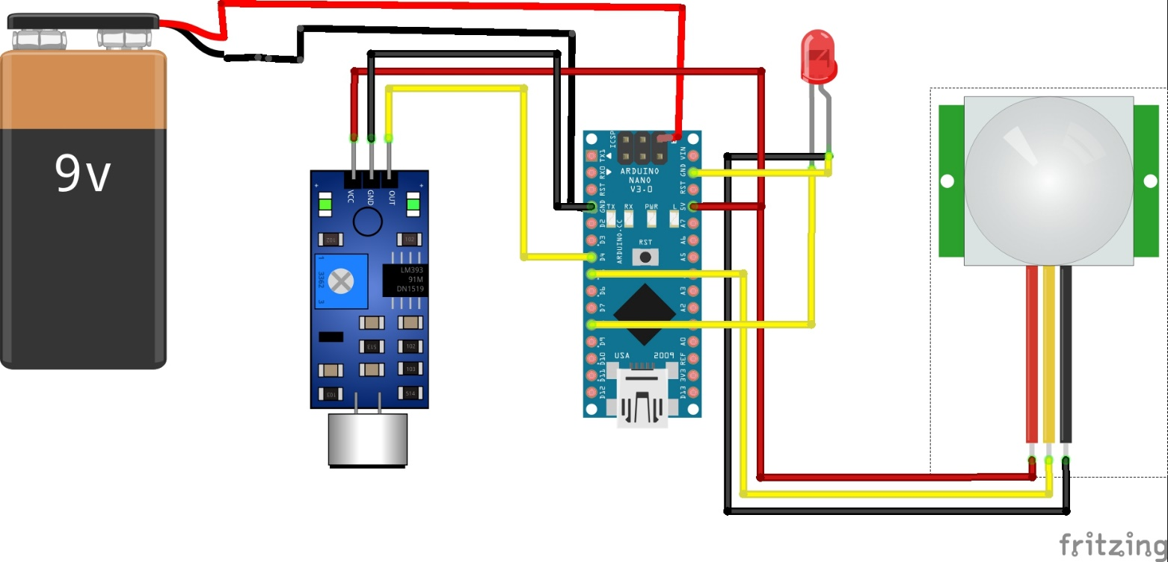

**PROJECT IMAGES:**

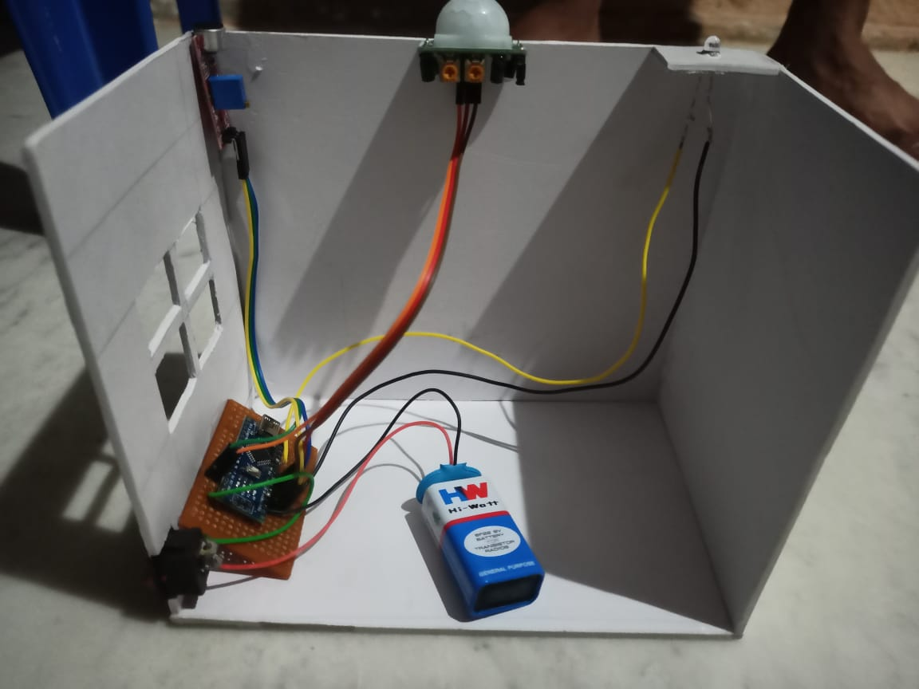

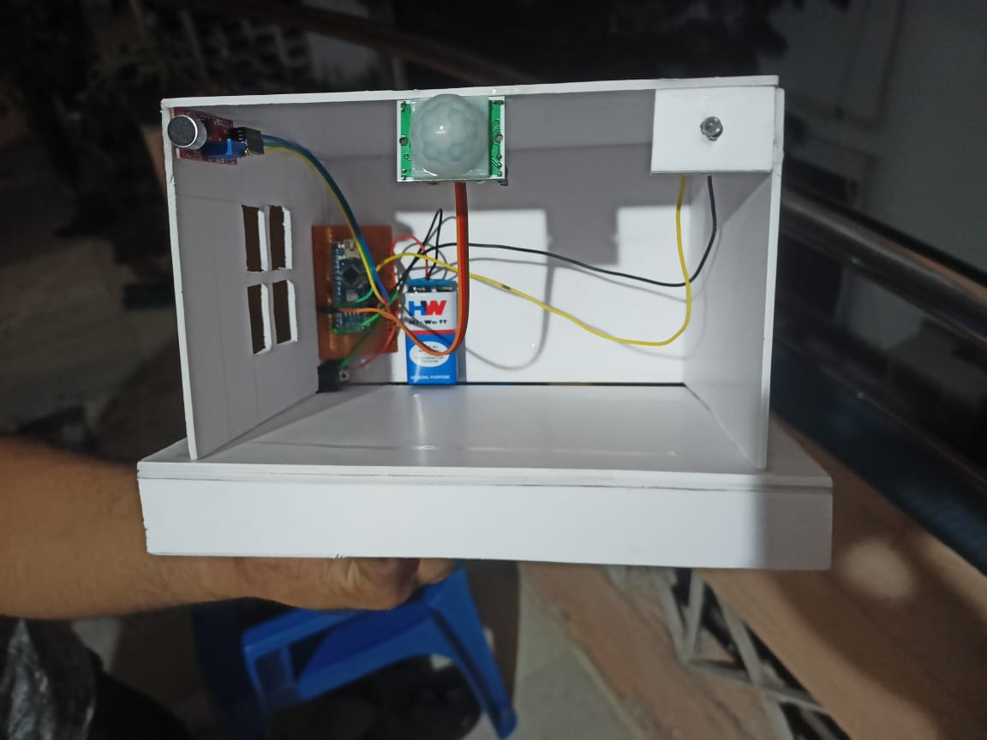

**RESULT:**

This project is a low-cost home security system which can also be used in the museums to protect valuable things and can be used as an automatic door bell circuit that rings the bell when human is detected. It can also be used in defence applications to detect the humans in war field.